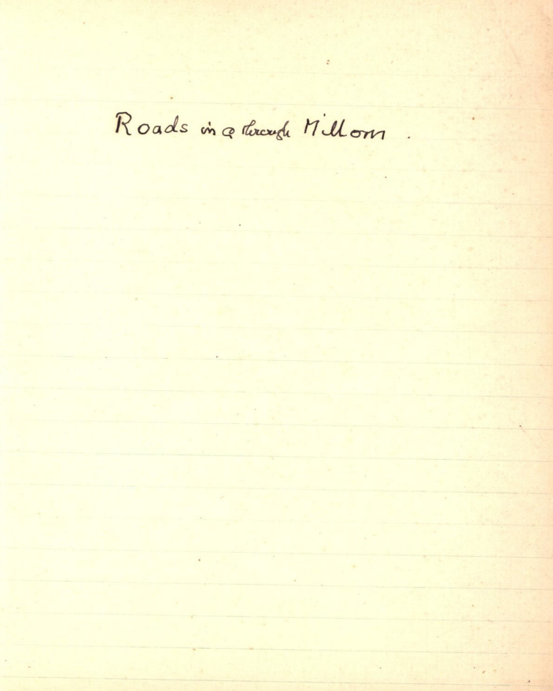

Abbreviations
C & W Transactions TCWAAS Transactions of the Cumberland and Westmorland Antiquarian and Archaeological Society
F. FCB The Coucher Book of Furness Abbey

1
The history of roads ancient mediaeval and modern is perhaps one of the most difficult of problems in any particular district.
The old roads of England have been described by many authorities – but I have not had opportunity of consulting them. If there is a caput or natural centre there must be roads radiating from it or others approaching from more distant places of importance.
The portion of South Cumberland under consideration known in the XIIth century as the Lordship of Millum is bounded on the North West by the River Esk and on the East by River Duddon. South West by the sea and on the fourth side by a chain of high hills. Esk Hause, Hanging Knott, Ewer gap or Orscarth, Bowesfell (2950ft) Tarns of Bowscastle Longtop Midfell Adam Crag (2660). Cold Pike, Red Tarn, Pike of Bliscoe Black Cragg The 3 shire stone to Cockley beck – Wry nose bottom and the Dudon (sic).

2
It should be remembered that the district described was an outlying portion of the great forest known in later days as the Forest of Copeland and the forest of Derwent Fells. Much of it preserved its character till 1280-1300, and even long after that Forest Laws, Foresters and Forest Courts still maintained a hold of the districts although in the valleys the many small farm holdings were pushing back their intacks and grazing grounds farther and farther up the hill sides and there must have been at an early period footpaths and occupation roads and sheep and cattle drives connecting them.
It is not till the English or Anglo Saxon period that these can be closely followed but in the older days were some centres of which little known history remains. Just outside the District were two circles one called now Swinside with a scattered group of hutments and earth works on Burnmoor – Eskdale

3
and more recent discoveries between Miterdale and Wastwater. From these was an ancient road part of which survived into last century as a church road to Eskdale. And the road over Burnmoor is in one place called ‘the red’.
Another British settlement is now called Barnscar which also had its ‘red’ road from Ulpha to Waberthwaite. After the time I left the district another series of old British dwelling places have come to light along the edge of the fells above Corney – and though no British name can be ad[d]uced there is a road through there also in the direction Corney to Ulpha.
On the coast line the remembrance of at least three circles traces in what is now Whitbeck. They are Gutterby, Annaside, and Hall Foss – and believe them nearest the latter passes the main road of the district. After a few miles from the latter are the Two Standing Stones of Kirksanton and

4
the Kirk or Rath and two small circles of Lacra – and an ancient footpath now I think closer between the standing stones and Lacra and perhaps extruding beyond it – vid p. 23.
Lastly is one of the best circles of all still well preserved ‘Swinside’ above Broadgate.
Very few British names survive although there are some, of which modern etymology does not seem to afford a satisfactory explanation. The only one I quote here is the Swin-side of the three circles. This I absolutely refuse to believe is derived from the Saxon word ‘a sow’. There are 3 Swin circles and a Swin court as well as a Swin how all connected with British places and there is no sense in the “sow” argu[ment] unless it be believed that the Saxon settlers deliberately tried to defile the places set apart by an older faith by turning them into pigsties. At Kirksanton they did not do so but built a church near it and called the place ‘Santes/Sunken Churche’

Bel - may be Bu. It seems not to be itself a water word but is often a hill near or overhanging a water place or stream. It has in Eskdale been associated with a place where the Beltain fire was lighted. And in these instances I know overlooked what is now a Church.

5
It is here necessary to speak of a particular line of road. Roads of the British type have not the mathematical (with exceptions) precise straight point to point direction of the later Roman road. But in one road there is a certain directness.
Swinside on Burnmoor – down to Belhill in Eskdale – now S. Catherine’s Church – uphill by Whincop and Birkerthwaite to Crosby Thwaite – between the two latter avoiding Kirk fell the direct line. Crosby Thwaite by Old Hall Ulpha to Swinside above Broad gate then slightly around by Knott Hill – by Broad gate to Hall Thwaite, Hill Millom – To Castle – Church and another Bel-hill. The whole road deviates very slightly from a straight line Burnmoor to Millom Church.
With it are connecting trackways to Barnscar – Corney hut circle – Kirksanton – and Whitbeck circles.
X in later days this is said to have been the road to Kendal. The continuation by Old Hall Ulpha and Kirk to Duddon Wathe is therefore probable. The Old Hall and Church of Ulpha seem an important centre.

6
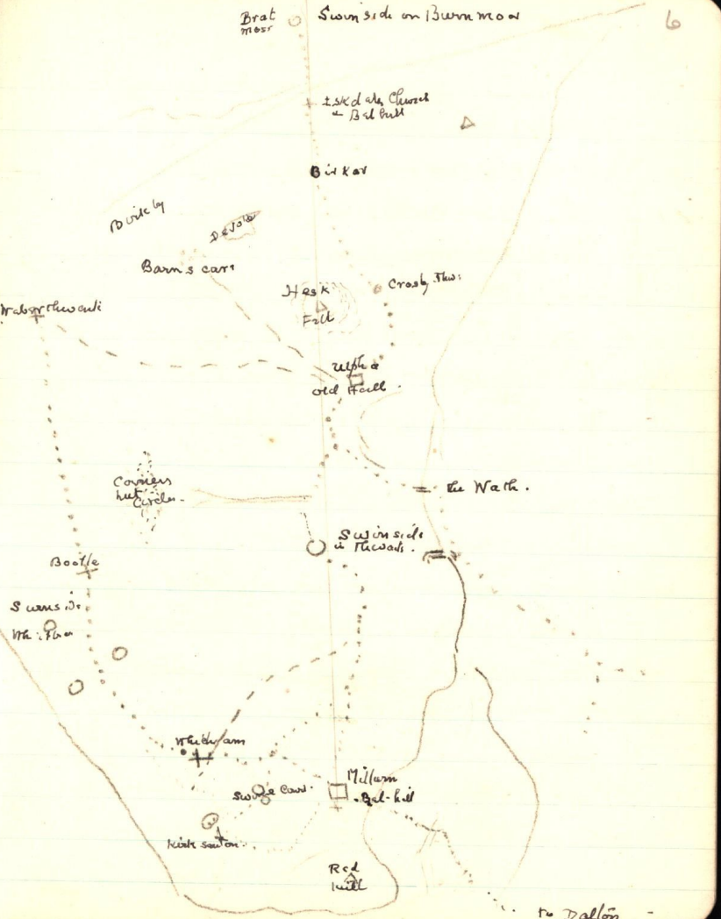

7
Notes on the map.
A. a traditional footpath exists between Swinside above Broadgate via Bowscale to Woodend or Devoke Water.
B. Before c 1730 “a very ancient road existed from Ulpha [Old Hall] to Barnscar”. Aaron Marshall.
(c ) near the present road over Thwaites Moor is a sunk or Holloway road 5 ft diameter in direction from the Wath of Duddon (Beckside or Duddon Hall] to the Priors Park of mediaeval history.
(d ) From the Two Standing stones in Kirksanton to the Circles and Old Kirk of Lacra. Query did this continue. There is an almost straight line of wall to High Loft scales as if this foot path Joined or perhaps more likely crossed the ancient Millom to Whicham road which is to be described presently. If continued it must have done so via Dunning Well to join the road to be described in the following page.

8
The Swinside Road.
Whether there be any connection between the Keswick circle and those of South Cumberland must be for some other investigation. It would probably be round Lingmell to Styhead. The straight line from Keswick to the Eskdale Circles is over the top of Sca-fell.
1) A road from Swinside on Burnmoor to Eskdale Church is still known as the Church road from Miterdale head. It probably was in use before c 1300 – and in fact far older. Eskdale Church occupies the site of Bel-Hill.
2) From Eskdale Church via Whincop to Birker thwaite a church road as early as perhaps c 1300 but is really far older – the original road to Kendal before the more modern road from Dalegarth ford and the later Bridge.
3) Birker thwaite is probably of British origin cf. Birkby and Brats moss close to Eskdale surely British before the Saxon Thwaite was added.

9
Then on to Crosby thwaite via the White Walls ancient Br: line of ?. The origin of Cros-by was long a puzzle. But Prof Eckwall indicates several places where ‘Cros’ is the Br! CRUG means a mound or hill. Either might be correct.
Crosby thwaites has its “Borrans” field but the road has diverged from the straightline because of the hill Hesk Fell which as maybe noted blocks the direct line between the two Swinside Circles. There is a similar name in Whicham v called Cross a bank with its thwaites (now Beckside) is called in a Furness Charter Oresthwaite – almost certainly a misreading of Cross thwaite – a bank or mound or hill is evidently part of the meaning of the name.
4. Crosby thwaite via Baskel {Baskel and Bowscale are rather confusing}to Swinside – or Horseman gates – a fell boundary mark - the modern road to Ulpha bends left. The old road is to Baskel in Ulpha & Old Hall Bowscale in Thwaites Fenwick – Swinside.

10
I never had opportunity to make local enquiries but my informant a man called Harrison who knew both the Eskdale approach and that from Millom was positive that such a road formerly existed – a local – or occupation road still exists except for the short distance from Bowscale in Thwaites to Hodgewifes well above Fenwick.
5. The Old Hall and Old Kirk pulled down as it is asserted at the end of XIV Century. The destruction of the Kirk traditionally was the cause of a great struggle between the men of the moor and those of the valley. The belief in Fairies still exists but it is hard to get information because of modern ridicule. The Fairies or Farisees appear[s] to have been a survival of the British aborigine perhaps the little men of times gone even before Britons perhaps the pit dwellers – as there are frequent references where obtainable that they lived – holes in the ground. The Fairy Craggs near Baskil are still known as a place name. Be this as

11
it may – the neighbourhood of Old Hall and Old Kirk in Ulpha seems to have been a centre of importance or a caput to the neighbourhood before the mediaeval de Copeland family made it the Hall and built the church. From it radiates the following roads -
(1) road to Northern Swinside & to the southern area and to Millom.
(2) road to Barnscar.
(3) road to Waberthwaite ford & church
(4) road to Duddon ford – later continued to Duddon Bridge.
(5) road to valley settlement of Ulpha – and present Church.

6. Swinside.
Name “The Temple” may be of comparatively modern use. c/f “The Temple” near Rotherham was the site over built now of the Roman camp.

7. This road began in Eskdale at Bel-hill beside the Church. It ends at Bel-hill between Millum (sic) Church and the shore.

12
The Coast road through Millom.

To the better understanding of the road it seems necessary to refer to (get some details) the Domesday Book reference of Hougun. The Manor of Hougun consisting of two parts separated by the River Duddon. On the Cumberland side it contained about 57,000 acres and on the Lancashire side 48,000 acres to which must be added 44,000 acres representing the free manors described in connection with it [rough estimate]. It is noticeable on the Lancashire side that the smaller estates composing the manor are arranged in groups. And it would almost appear as if the surveyor – accompanied by local men to give required details – had in each case selected some high point from which to mark out the groups. In three cases at any rate they appear to be so. It must be remembered that though the survey was for a Norman & probably the clerk or surveyor was Norman – the details must have

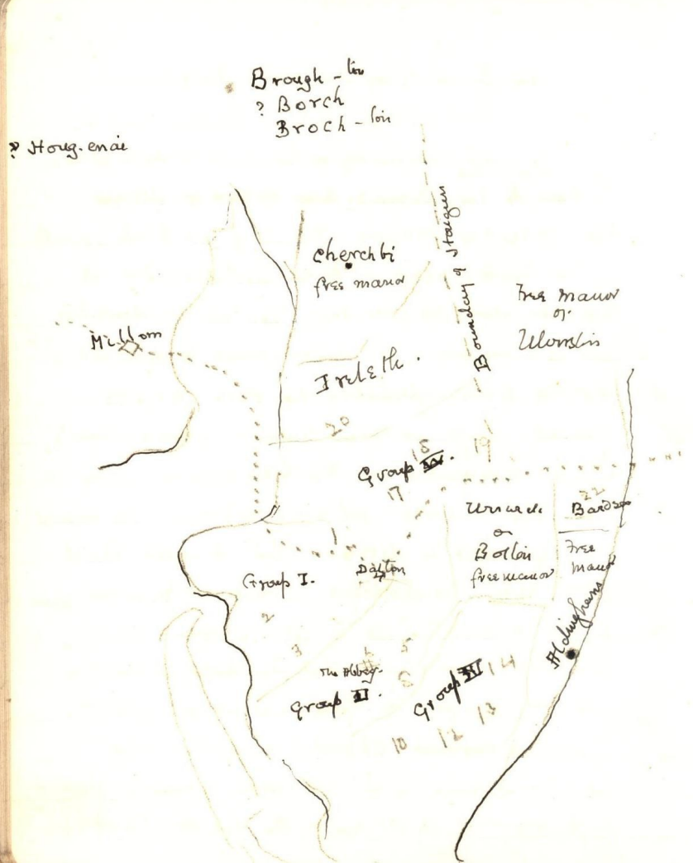

13
described by the Saxon holder. It should also be added that the line taken is left to right. This frequently happens in Saxon Charters but the right to left is more usual. Here probably the coastline necessitated it.
The groups are
1. Dalton group. Surveyed from near S. Helens chapel (of later history)
2. Newton Group (Wart = the beacon) (also a beacon by Furness Abbey
3. Leece & Gleaston – part of the site of later Gleaston Castle.
4. Marton & Pennington group surveyed for (?).
5. Not a group but taking account of free manors. Ireleth on one side with Church Kirby (free) beyond it and Borch beyond the free manor [Borch is much disputed but most probably Borch – Brock – Broc – and later Broc-ton. Bolton including Wreake omitted being a free manor / And Ulverston – free manor.
The last name is Bardsea – which should have been mentioned first or second in the list if Urswick had been the caput.
It is noticeable that all these groups have a certain connection with the great Coastal Road
14
The surveyor names the Caput & demesne lands of Hougun. And at once proceeds to the most fertile part of the capital manor and describes Low Furness - formerly up with Bardsey – which is stated would have been mentioned quite early in the list if Urswick had been the caput.
Then he crosses to the Cumberland side but makes no mention of Millom unless he has already done so. If he has – it would be quite in order in a Saxon charter to omit a second reference. The first place named is Whicham. It should have been Kirksanton following the road to valley from high ground. Thus he should have named Hougenai if that had been Whitbeck – but he names Bootle as the ultimate place of his survey. Then he returns to Santachurche (sic) – and again omits any reference to Millom which he seems to pass then he names Hougenai. If he has followed the same method here as in Lancashire Hougenai on Cumberland side must be either Thwaites or Ulpha . Birker or

15
The coast road commences near Lancaster entering the sands near the mouth of the R. Keer – crosses the Eau the chanel (sic) of the river “where a guide on horseback called ‘the carter’ used to wait to conduct passengers over the ford. Then landing at Cark and 3 miles overland through Flookburagh (sic) to Sandgate where it crosses the Cartmell (sic) sands and the Leven channel…to White Thorn at Conishead Bank…thence to Mountbarrow where pavement has been found. Crosses the Ulverston NB Turn Pike at Street Gate – Pass Pennington on the right and Urswick on the left with Gleestone (sic) beyond through Lindal with Pits up on the right and Adgarley & Stainton on the left and so arrive at Dalton.
From Dalton up to site of S Helens Chapel (where Prof Ekwall places the first name Chiluestreuic and descending thro[ugh] Croldrun to Roanhead and over Duddon Sands.

16
The passage of Duddon Sands is not described in Cooks Travellers Guide c. 1830 but was still remembered in general outline when I was at Millom – and the Guides House is still marked by a tablet on a house in Holborn hill…the last guides have also been elsewhere referred to and that they marked or “brogged” or used branches of trees to mark the course. From Roanhead the passage took a line to what is now the end of Askham pier and bending outward into the centre of the sands till opposite Borwick Rails; here was the most dangerous part with several channels constantly shifting. But these are easily visible in ordinary light and prominent landmarks. Warr Knott by Dashat Gate or perhaps Midlow Hill both away to the right. To the left was Red Hill with Lacra almost midway – slightly to the right of the last was the safest and direct route to Millom Castle. – or in the old days the island on which were the two ancient places named Childrum and Bel hill.
(present day names used for identification)

17
But here enters the interesting question – why not to Holborn Hill? The answer is another question. Did it at time of DB (Domesday Book) exist? We know that where the monks of Calder had the salt works of Rutland pool close to the present Railway station – they had to obtain a right of way – and their road was at the back of the present Vicarage up to what is now Bay View Terrace and probably to the Pilot Inn – Holborn hill from the foreshore could not have existed on a public road for if it had existed no right of way would be necessary.
Then why not following the line of the Park to Beck farm – but as far as we know the Park was owned by the de Boyvils at least 50 or a hundred years after DB.
The only alternative is as suggested to the site of what was later Millom Castle and which in DB appears to be called Hougun. But where then? The Thwaites road might be in existence but is the wrong direction for coast line. The Mill might be in existence and if so some small lane or trackway led to it but reasons will

18
Be given later – page 32 – for believing that the road by Old Cross Howe/ House and Langthwaite could not be the main road.
The alternative is by what still exists as a right of road – the footpath to High Lo’scales which passes through the Millom Park & so this perhaps may be a reference in a charter of Sir John Hudleston dated December 19. 1292 where reference is made to ‘right of way’ through the Park and other enclosures existing at that date – is at present existing – this right of road passes High Lo’scales and joins the road from Dunning Well or Applehead to Pow House. High Lo’scales may need examining for traces of an old road from High Lo’scales to Gray Mare boundary mark of the Township of Kirksanton. But I am not persuaded that this suggestion is justified.
From the above named junction with present road this ancient way descended to Pow House once the possession as appears by a charter of Sir John Fleming of Beckermet – then a

19
Map to show passage across Sands and through Millom
1. (not shown on map) Chiluestreuic or S Helens Chapel.
2. Chil-druime later Holy Trinity Millom. Also Hougun the Caput
3. 4. 5. Red Hill. Warr Knott. Highest point of Lacra. Pointers for danger & safety points in the Sands. To 5 points safety.
6. Whicham Hall Just off old Road. 7. Lacra. 8. Pow House.
9. Dangerous crossing over Sands.
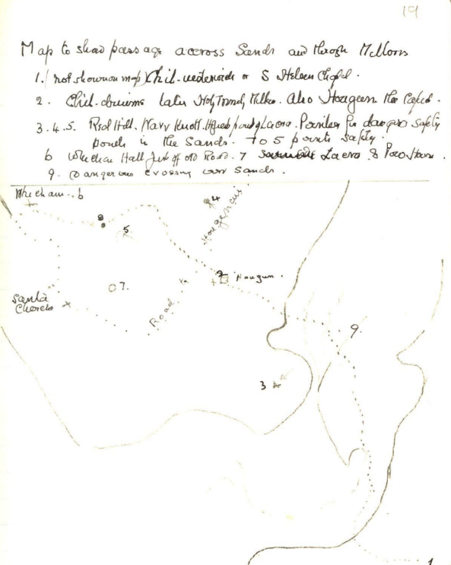
20
Marriage – apparently with a de Boyvil – the road then passes round the head of what once was the Pool, from which the name Pow House, and ascends the slope and follows a footpath rather than the present existing road to Whicham Church and between the Church and Rectory to emerge on the top of the hill above Silecroft joining the main road at a point just beyond an old Tavern or Inn. From this point to Bootle and perhaps beyond, the road has been named “The Street”.
Following the custom as in Furness the DB surveyor might have viewed the district from the top of Lacra – or less likely the lower spur of Black Combe above the place ‘where the Street begins omitting Millom already named as Hougun he enters the name Whicham the first place on the old road – Whitbeck Manor not then existing. The next names Bootle and following the view left (or contra clockwise) direction for the names
21
Santa Church and looking further away (again omitting Hougun i.e. Millom) he sees the uplands beyond Thwaites Ulpha and Birker and the upper valley of Duddon and named them Hougonai – which I bring now an etymological word describes as Houg-ean – thus High[l]and of Hougun.
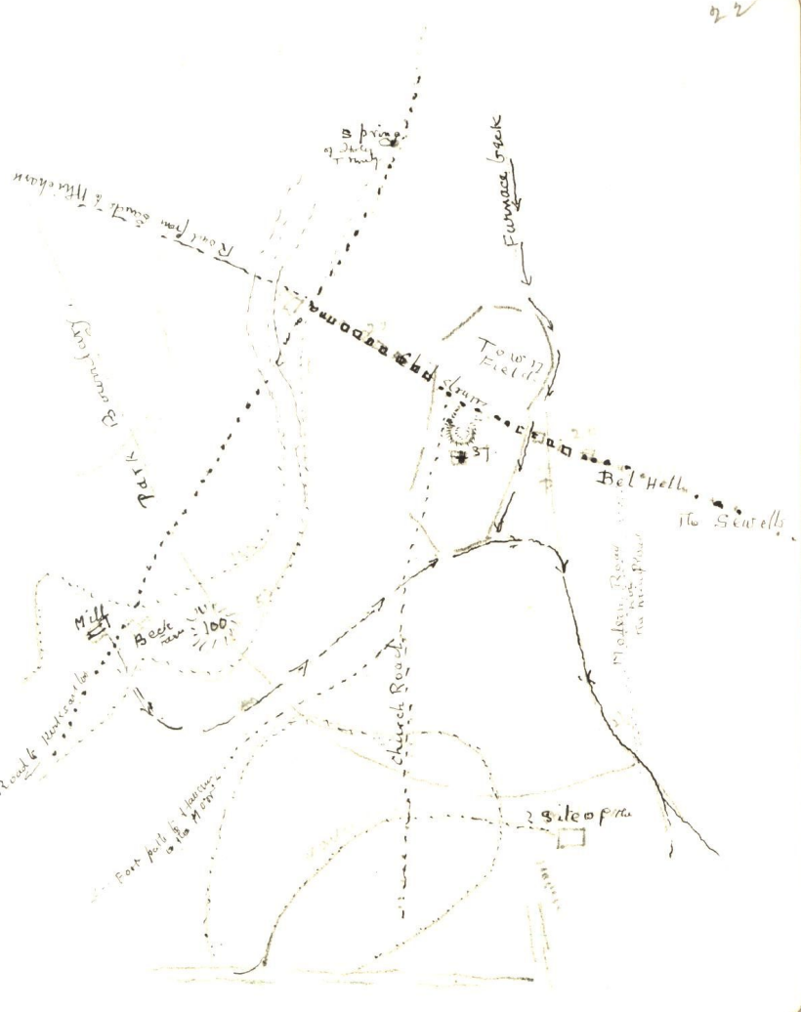

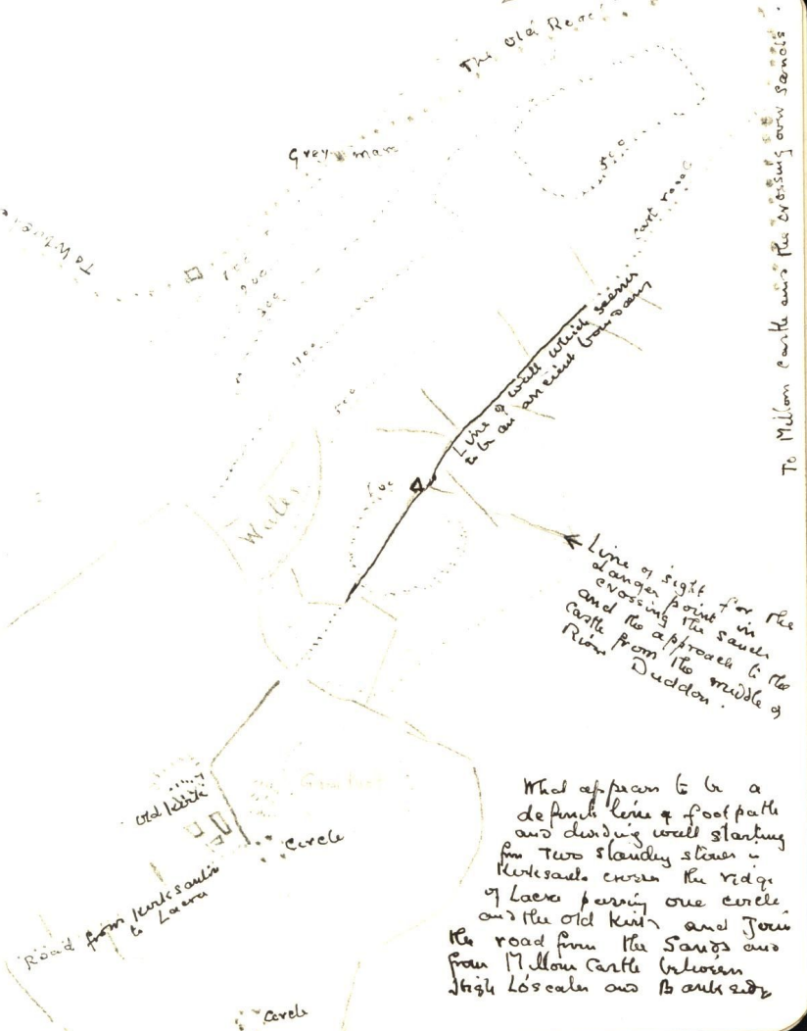
25
Whicham Valley
This road is assuming more and more the character of the main thoroughfare between Broughton and Bootle. Its origins may be
(1) a British track between Broadgate Swinside and the 3 circles at Whitbeck by making connections near Whicham Rectory with the old road across sands. The upper part of this connects in Swinside Temple, by a footpath which still exists over Knott moor and the shadow of Knott hill to Knott End farm; then either by a) Bayston Bank – the present outlet or b) by Grice Croft and Whorl Pippin to form a union with the road from Chappels –
or
(2) although a Br: trackway might still be used this road appears eventually the linking up of many farm settlements of the Saxon period. The 1 inch map is too small & six inch too large to show how each farm seems to be

26
linked up with the central trail down the Valley.
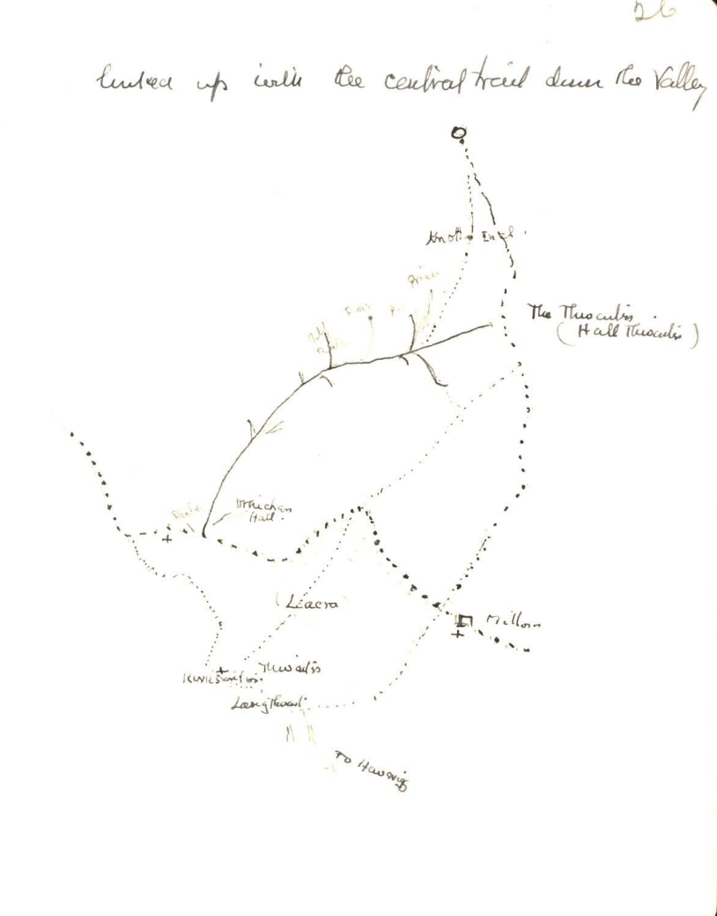

27
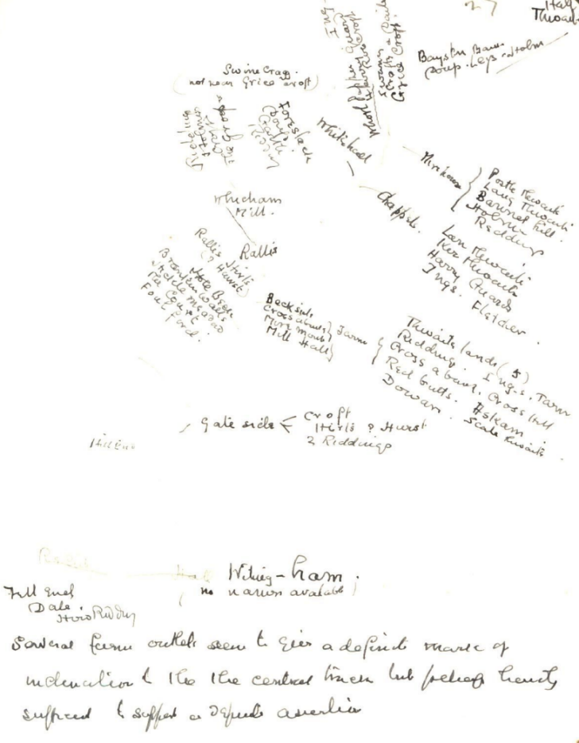
Witing-ham
(no names available)
Several farm outlets seem to give a definite mark of indication of the central track but belief hardly sufficed to support a definite assertion
28
There are probably many other roads which may have origin as a Br trackway but which hardly came into existence as roads until the settlements or farmsteading of the Saxon period pushed farther and farther up into the recesses of the hillside.
One such may be noted ie: that following the course of River Esk from Waberthwaite through Birkby to either Crosthwaite Brig or going up fells towards Devoke & this road was still repairable by the individual owner or occupier of the land through which it passes and was almost certainly a loop road for the various farmers.
Such also appear to be the origin of the connecting roads between “The Green” and the ford of the Duddon first at Wha’ and later at the existing Duddon Bridge and here we are met with two difficulties
1) date to be assigned to the Bridge.
2) there are 3 ways from the Green to the ford.
I am inclined to place them in following order

29
1. Commencing at the stile side a little below The Green – there is a connecting lane with Old Cross House on the road from Millom – and from stile side direct to Arnaby Farm and through the farm. In a deed report to Bla’holm F ii. 534 no 32 c 1230 this seems to be called ‘the great road’. It may however be road No 2 below where is such a great stone.
From Arnaby to Roanlands and then joined by No. 2.
2. May be the original
Commence at Arnaby Mill and follow by the side of the Mill race and by Red Brow ^there is a large stone in [the] hedgeside^ then almost to Hall Thwaites but bearing away to the right to Elf Hall and Lady Hall [? In Lady the Lath a prominent boundary or road mark vid other lath names] to Low Bog House.
This road needs a good deal more description – e.g. other places Jacks Folly – Spring House the ? to ? ? later with Causey Lane.

30
3. The present existing high road.
I am under the impression that this was either new made or constructed when the Surveyor of high roads came into existence. It may however date (or be older) to the time when the Duddon Bridge was built.
It is true that various Farms or modern mansions? now connect with this line but I am not certain that their present connections have led also connecting link now perhaps d? with road No 2. above. And although for convenience the high road (No 3) made quicker travelling I think that I passed along the No. 2 road more often and my memory does not carry many details. Just before reach Slape sluice however there are two fields of interest “Monklands and Gate lands Yet’. I am not certain whether the latter name may not belong to the road or ‘Yeat’ or ‘Yet’ is gate. Perhaps & more likely they both belong to a later series.

P31 missing.

32
The Kirksanton Road
Reference has frequently been made but no reason given why it appears of secondary importance.
It is noticeable in many places that where an ancient pathway has to cross low ground marsh – river or even stream the narrowest point is chosen even if this entails a round-about approach – a good instance of this is the Waberthwaite ford. The road from Ravenglass curves right near the Knott to approach it from Millom side – Waberthwaite Post Office to Bedalmer Lane and so to the ford.
A much simpler instance is the old road over Pannett Hill – and round the Park boundary to High Loftscales in the narrowest place e.g. to Beck Farm. The Castle ford is another.
In Kirksanton Road – this begins at Whicham Hill foot ?? Plough Tavern

33
From 45 ft at the sign post Whicham Valley road it descends to 36 and then has to make a detour round Arrow Marsh & the present road skirts the 50 ft level for most part of the way – but the marsh must have been much deeper before the Heleupul was altered & land drain. Probably the road was only passable in dry weather. And we know from the Charters that are as late as 1200 and nearly to 1300 a series of pools & lagoons existed from Pow House down nearly to the Meles and between Standing Stones Farm & Silecroft marsh and mosses made the amount of dry land small. Kirksanton itself was a slightly higher level and from the Mill the road rose and fell frequently till past Hestham then Langthwaite of which the principal ridge is now called Little Langthwaite – and by great Langthwaite the beck crossing the road might generally cause little trouble except in winter period.

34
Beyond Little Langthwaite the road drops 17 feet – present day level to about the same as the present road between the castle and Low House. At the Old Cross where the road over the Knott commences the B Mark is 29 ft. If before AD1200 the road continued from this point it probably only did so as far as the Palmer Lane which at that time was probably the Church road ⃰ i.e. footpaths from the Moor and some parts of the low demesne.
⃰The Church road is referred to by Philip de Vermeles Vicar of Millom. From the church yard it crossed the marsh probably by a raised footpath as step stones. At the rise of Pannett Hill it provided one path to Holborn Hill (circa 1230) the other to the Moor.

35
The Park
It is generally supposed that this was done by the de Boyvils of the Castle but I believe so far no evidence is known. To me the most probable appears to be Henry f Arthur c. 1180 to 1210.

The only difference it made to the road was perhaps
(1) To divert the ancient road from Lo House by Loscales to the outside of the Park boundary i.e. from the Salt House Gutter behind the present Vicarage over to Pannett Hill – by shortest crossing over the marsh – to present site of the Beck Farm – or rather to the Mill then back to the Park boundary and just outside it to join the old track at High Loscale.
(2) The Dashatt Gate connection between the Thwaite road and that from Lacra to Apple Head a road to the park Head – is perhaps a Foresters’ house or rather in this case the Parkers.

[N.B. there is no page 36.]

37
The coming of the Monks.
1. c. 1145 lease of Kirksanton & probably some land in Hougun – but no occupier of land.
2. c. 1160-70 the sheep farm of Meles of Kirksanton how were these conveyed. Probably via Millom Castle & over the Knott & the hill side (unenclosed) along the Marsh road. But constant usage of this road must quickly have contracted to the monks for some improvement – perhaps these the first road improvers?
3. Permission by Henry de Langthwaite to pass freely through his land. Beginning of Wanesgate road to Havrigg Haws But Gilbert had before that given land to Cockersand and Havrigg itself was an important sub manor? under Kirksanton. The Kirksanton marsh road must have been under ? at many places.
4. Henry de Millum granted his son in law land in

{Sykes added a side note to page 37.} It reads:
Perhaps at first to the Mill [Beck Fm] (Modern names used) and so to Old Cross – but a nearer way was obvious – from present Bay View to Pilot Inn and down the hill.

38
Kirksanton – perhaps for a residence as he seems also to have had land near Pow House – Sir John Fleming’s.
The Road over Loftscales probably declined as that to Kirksanton was improved.
Henry de Millom also seems to have made the first grant of Saltworks etc to Calder. This was just outside the Park or boundary at the Ruttan pool - they perhaps also had a leat from the stream called the Wyre for fresh eels. They no doubt used the road outside the Park boundary to the top of Pannett Hill. Perhaps they used an old path or made one as it was outside the Park to the bottom of the hill by head of Palmers Lane (not then existing) to join the Kirksanton road. An easier route for laden animals than over Loscales.
Perhaps also these Works – employing local labour – covered the beginning of houses now called Holborn Hill. If so it would not be long before such workmen made their direct route to the works. So we get Holborn Hill as we know it. But its name Howberg perhaps of later date when the monks fishery in Duddon commenced.

NB. Several of these entries need transposing – as the dates should have been observed.

39
Transpose 6 to 5
5. William of Henry de Millom gave the Salt Works in Kirksanton. Horses & oxen & Cows as well as sheep now belonged to monks in Kirksanton and further improvements of the road must have been made as a constant backward and forward traffic of salt one way and provisions of all sorts the other way must have been a daily occurrence in summer – the period of salt boiling.
6. Henry de Millum gave his daughter Gunild the land of Lekely in Bootle on her marriage to her cousin Henry of William. She became a widow at an early age perhaps Henry was killed in some battle. She gave to Holm Cultram the lands with pathways also extraordinary right into the lands of the Forest.
6.Adam f Henry (de Millum) gave a Salt works at Slepul near Lady Hall to S. Bees c.1230 – how did they convey the salt?

40
Perhaps this is the origin of the Pack horse lane through Gornal Ground (vid a later page) which continued to be used as such till late XVlll or early XVlll century. Descriptions of Pack animals passing along it were few to none – no doubt traditional.
[Note transpose 8 c 7]
7. John de Hodelston I gave and Lady Joan confirmed to St B. certain pastureiges in Grassholm.
This was probably connected with the ancient forest road from Wha’ to the ford across Duddon to Bootle & Corney – or rather in the first instance ancient British saltworks on the fell side above these places.
At any rate St Bees probably had a connected route from Lady Hall to Bootle. And also obtained a few years earlier in Bootle a ½ acre on the Corney Road in the parish of Bootle – & pasturage for 1 horse or 6 beasts together with a small sheep or goat pasturing. But it is also possible that the St Bees Pack Road was via Boot and Ward and land.

41
8. Priors Park. The pasturage was given to Conishead before c 1220 by Alan f Kettel – and leave to enclose by John of John de Hodelston c 1250. The approach to it was doubtless from Wha’ the ford of Duddon and along the edge of the moor above Thwaits’ Yeat. – the road sometimes referred to ? which originated perhaps in the Br. settlements above Corney.
9. Visiting Jerico – I asked the farmer of Butterikeld how cattle were probably transferred between Jerico and Furness Abbey. He replied that – pointing out a route – there were traces of a very ancient road into Mosedale and by Gaitscale beck down to Cockley and Blackhall – but from there he could not say which side of Duddon was most probable. I am only familiar with the road on the Ulpha side

42
but the crossing of the Duddon – if it was the Ulpha side would probably be at the Wha’.
For 40 or 50 years this was perhaps the usual cattle route – whether the cattle paid toll to Millum castle I think is not known, nor is it I think known when Duddon Bridge was built and replaced the ford. But assuming – till proof is forthcoming that Sir John exacted toll – this would account for the disputes or claims of Patent Rolls 1300 when Sir John seized & compounded the cattle of Furness on the way to Butterikeld.
This would also account for a new route adopted as their cattle road by Furness Abbey. Dates are unfortunately not to be depended on as in Fii, 549, 550 there are no witnesses names. William de Thwaite was a free tenant under Millum – what ever that may mean – and he made a grant of free passage both for cattle & conveyance of goods. With the

43
grant in a certain field and a spring of water – in one place – also a place to detain sick cattle outside the limits of the Township [NB quarantine].
What is the line of this cattle route?
From Abbey lands in Furness
Route 1. By Kirby & Broughton and pay toll either at the Bridge or at Wha’ ford.
Route 2. Cross sands to Millum Castle & pay toll…
Route 3. A new route. At centre of sands cross at the safe point (vid p…) but instead of going to Millum Castle go a little further up the safe sands to Thwaites beck i.e. The Strands and up the road to the Green. Where herds now obtain harbourage at what is now the Punch Bowl & cattle may rest in the field where the spring is. Then all the way through land of William de Thwaites – a free tenant
44
through Hall Thwaites to the Broad Yeat and to Cragg Hall – passing Beck Bank where are step stones leading towards fields outside the township or rather well away from the hamlet of Hall Thwaite – called Monkland – safe quarantine for animals which have been injured or become debilitated during the difficult passage of the Duddon sands – then by a definite track crossing the road from Wha’ or Bridge and towards the ancient road Ulpha Hall & ? and by Crosby Thwaite to High Birker – but no longer by the old footpath through Wha’cop.
The road into Eskdale was established before that but either through the ford to the main Eskdale road or more likely the old road on the Southwards side of Esk by Pennyhall and the old Piat Nest tavern [NB Where the mediaeval Diptych was found] to the Cowpastures the first field of Butterikild where the cattle might rest before going on through Butterikild land to the Linco?

45
The Pack Horse road & Gornal Ground.
The road from Spring House near Lady Hall to Gornal Ground was described to me as a paved road, probably Roman as all such roads were generally supposed to be with a kind of circle beside it ? in popular mind fine circle at Swinside & others.
I have traversed a good part of the road before 1900 but know of no explanation of the enclosure save that a lost circle was being searched for. Of the

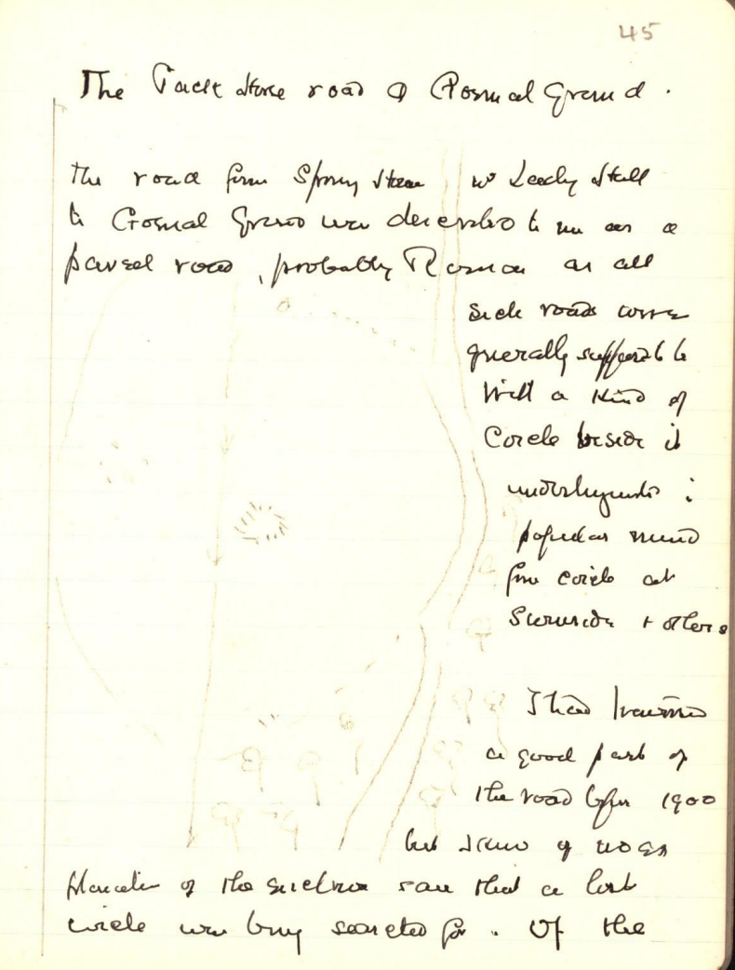

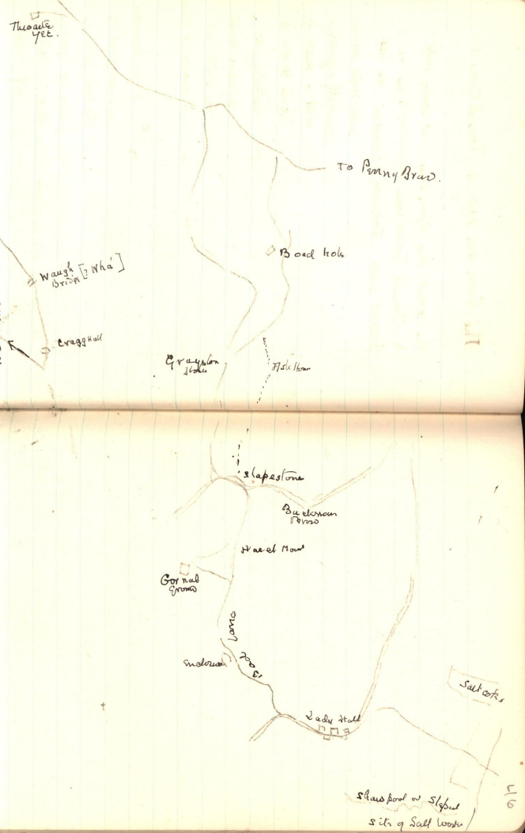
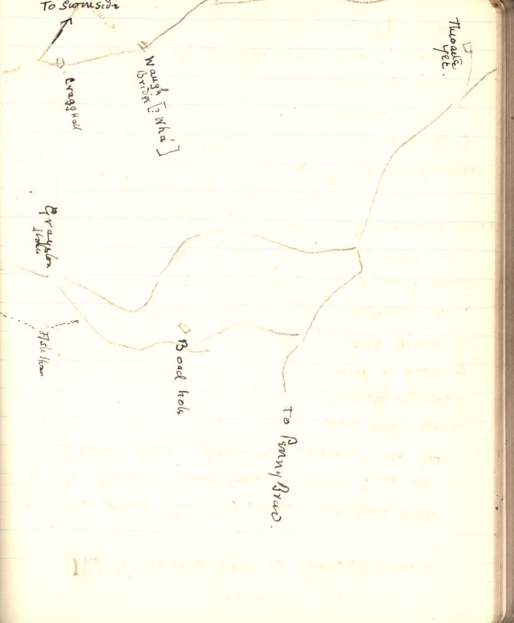

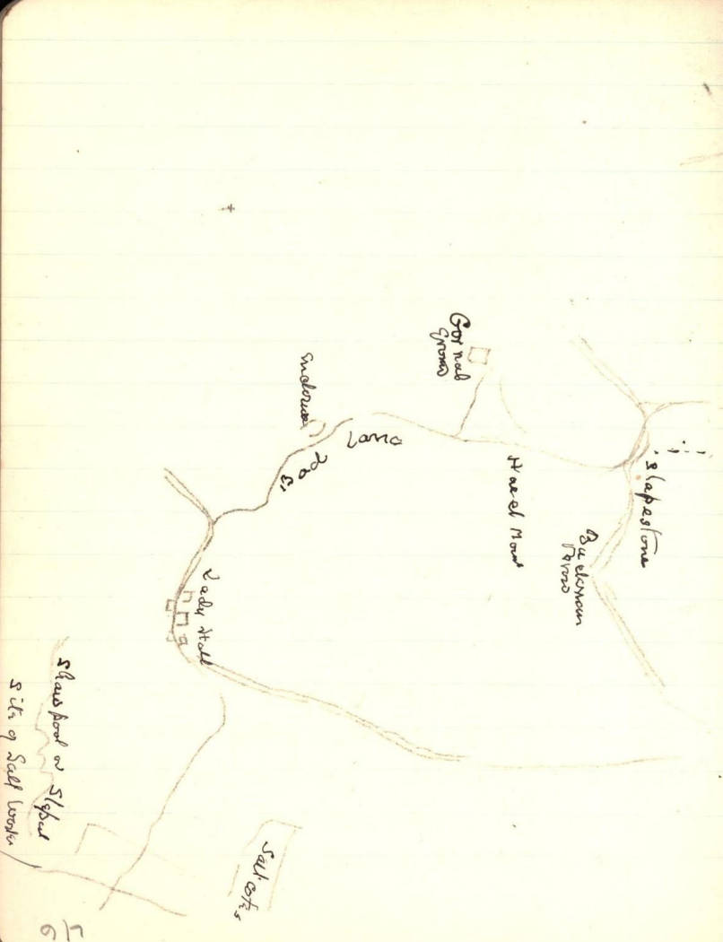

47
road however I recalled definite traditional accounts of horses and men passing over it during the night – smugglers perhaps as it was described as within recent memory. I had opportunity later to trace several parts of the road on different occasions
(1) The Bad Lane to Gornal Ground & the high road
(2) The upper part of the road between Slapestones and the moor; and have to notice several places in which pavement existed below the surface also the very narrow width.
(3) Also from the moor – one exit by Boadhole – but unfortunately I am not in possession of notes that I need.
(4) finally with Mr Sherwen Vicar of Thwaites who took me to see the site so far as he knew it of the Salt Works of S. Bees in Thwaites. I believe we did not examine the proper site. But he did show me the path from Caser Lane to Lady Hall – and ? discovered the probable site of the salt pans – ? called salt cote.

48
In C&W Transactions 1902 a comprehensive account is given of the Gornal Ground enclosure and the road passing it. Perhaps a survey may be map of as on “narrow and sinuous pack horse way which connects Gornal Ground with Lady Hall” and on p73 is described a sort of resting place – sheltered and affording a good waiting place for the tide of the estuary to afford safer crossing or in the reverse direction a resting place after crossing. Added to this was a kind of “village smithy which would give facilities for repair of gear & horse shoes”.
The writer might have added cattle shoes also for I know from local information that cattle making a long trek through Kirksanton wore often shoes with metal plates.
In the C&W article the writer refers to the crossing of the sands at the causeway which he connects with the road from Ulverston. One needs then only to be

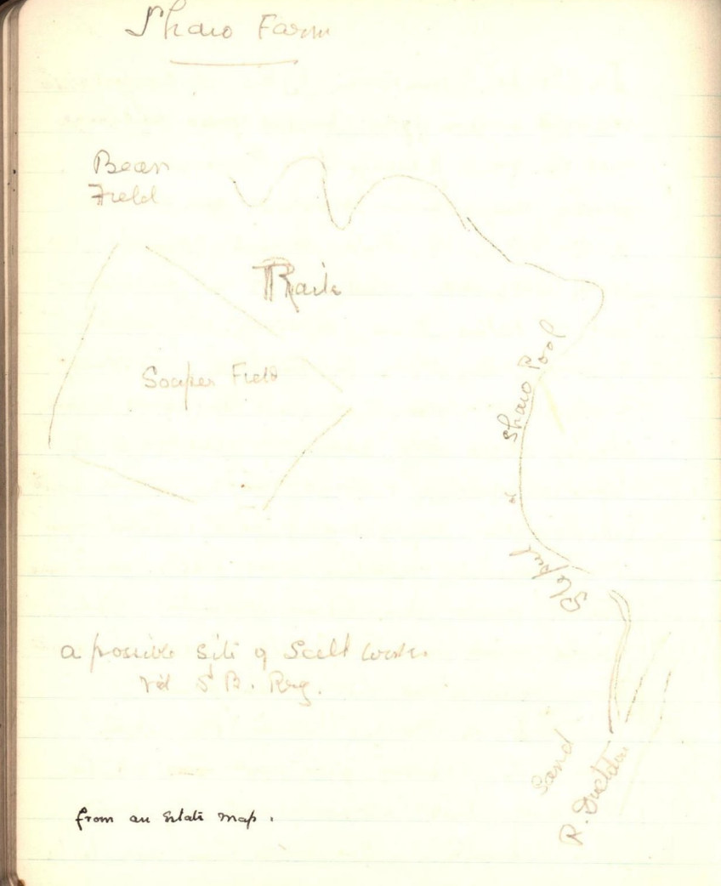

49
further reminded that though a British track is not without possibility the mediaeval ones might be
(1) From the Saltworks at Slapest. to St Bees.
(2) Cattle from Conishead to Priors Park.
add (3) in later days ‘smugglers’.
The road itself.
As our district commences at Sandside in Kirby and crosses Duddon near – perhaps above the present Furness Railway Viaduct.
The Causeway or Caser Lane is first of all a bit of straight road across the dryer sand and then across two fields to Lady Hall. The salt cote field is marked on the sketch map – probably it was the shore lagoon where the tide water ? and the sludge carried to the salt works - by the side of the gutter from Roan lands - on OS map it is called Shaw Pool.
*? Lady cf Lath – Ladder – or a prominent point ? a land mark

50
The road passes right through the hamlet of Lady Hall in front of White Horse Inn (? Where crest – or is it ref to Pack Horses) and as far as Spring House [the occupier ? ? of many horses passing through] and Bog House Brow where the road turns up to the right below Bog House woods and Gornal Ground woods. Bad Lane and the enclosure with Smithy is described in C&W vol II (1902) a very narrow wet alley paved in places to Gornal Ground. The road seems to pass through [but there may be also a side track] the farm yard turning to the back of Hazel Mount and to Stape stones. Then [unless there was a cut across the field] along the present high road for a few hundred yards. Then turn right to Graystone House or to Ash house. From this point there are two ways on to the moor. But I cannot recollect which I examined. I am under the impression that

51
it was Boadhole. In any case both trackways come to the edge of the moor almost at the same place. From the moor I have the following entry
JULY 19. 1900 ….. “from Logan beck we crossed the moorland to a point under Lath-rigg where four roads meet; or rather the fell road from Penny Brow above High Duddon to Bootle is joined by others
(1) from Cragg Hall by way of Waugh Bridge over Black beck
(2) a pathway through Wray slack from Grayston House
(3) from Boadhole.
One of the two last is certainly the line of continuation of the Packhorse Road from Lady Hall.

52
One other reference to road seems desirable
St Bees.p369, Note 1445 Application that Eskdale be raised to the state of a parochial chapelry because they were so far from the Mother Church of St Bees 10 miles or more – and that there intervened two broad waters and three streams.
This seems to indicate that the Church road from Eskdale was over Burnmoor and the head of Wastwater and by Ennerdale –
If this was the route from Duddon valley Saltcoates the distance must have been 35-40 miles.
By Hall Thwaites, Whicham Valley, Bootle, Ravenglass would be a little shorter way. But the Packhorse road and by Priors Park to Ravenglass and Gosforth and St Bees about 28 miles rough map measure seems nearest of all.
It is hardly likely that the Salt carrier of c1200 or 1280 would go by a road acknowledged in 1445 to be a very arduous one.

53
Between 1180 – 1280 or 1300 the monks of Furness were obtaining more and more freedom as users of the road for their sheep farm and Salt works at Kirksanton and for their cattle at Brotherkeld via Thwaites and the monks of Conishead for cattle via Priors Park and of Calder to their Salt Works outside Millom Park – and St Bees for their Salt work at Slepul (Lady Hall) and the priory of St Bees was also obtaining various rights and properties all along the coast down to Bootle.
The result of all these must have been that even for their own convenience as they were improving the road from mere tracks into some semblance of wheel traffic as well no doubt and personal road travel. And many small byeways originally only occupation road for farmers to fields were being opened out
The dissolution of monasteries perhaps carried a set back for some hundred years or

54
more – but the necessity of markets and communication with more distant parts of the country may have tended to improve matters until the time when parishes appointed their road surveyors.
When widening of roads or cutting off difficult corners & perhaps ? of ? ? roads ? – NB the old road through Cross House and perhaps the Buckman brow to Hall Thwaites –
Finally the stage coach – with a set back when Railways took their place and now motor traffic – due to ? we have the fine piece of work between Low House ? and Hill Millom – but deplore the ? ? road lost and above all the destruction of Milloms Holy Well – the true significance of the site of which did not appear till after publication of J. Brownbill’s Furness Coucher Book in 1916.

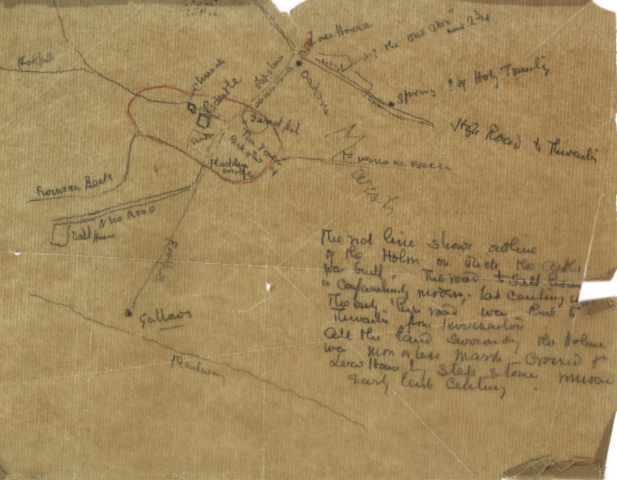

Wha’ Old Ford where is now Duddon Grove Bridge
FCB vol. ii, pt. 2, p. 535, no. 33.
FCB vol. ii, pt. 2, p. 549, no. 49.
FCB vol. ii, pt. 2, pp. 549, 550, no. 50.
TCWAAS vol. 28 New Series, pp. 393-394.
TCWAAS vol. 2 New Series, pp. 53-76.
FCB vol. ii, pt. 2, p. 554, no. 56, see also TCWAAS vol. 39 New Series, p 298.

